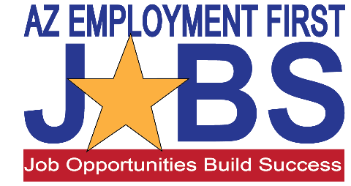

Oh Yes I Can Work!

Stakeholder Group:
- Review Your Group’s Stakeholder Perspective. What will be important to consider in crafting and delivering an effective message?

- Using the internet, find one or two examples of how EF is currently be addressed at your stakeholder level. What did you find?

Does it reflect and address Stakeholder’s concerns/perspective? Does it Appeal to the Emotion? What might be a more effective approach or message?

- Identify some of AZ’s “Bright Spots” and effective programs/practices. How can these be scaled up?

- Thinking about all the things we talked about this morning and the ideas shared, are there additional things that you feel should be done to reframe services, Shape the Path and encourage change? Brainstorm ways to improve “message EF and CIE” and “encourage change”. Come up with two new things Arizona could do to increase buy-in for Employment First at your stakeholder level.

