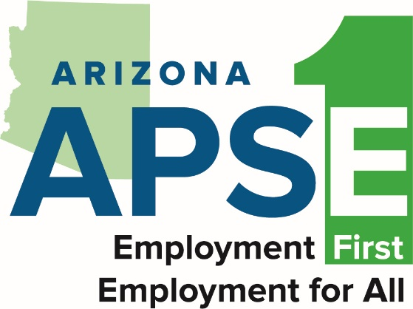
What is Employment First?
- Employment should be the first choice for people with disabilities in Arizona

- Getting a job is the expectation for people with disabilities

What is Competitive Integrated Employment?
- People with disabilities also get paid the same as people without disabilities

- People with disabilities work in the same place as people without disabilities

- People with disabilities do the same kind of work as people without disabilities

People with disabilities should have the opportunity to change jobs and build careers.

www.azaspe.org https://addpc.az.gov/

